HYMN 238 Angels We Have Heard on High (V.1&3)
Angels we have heard on high sweetly singing o’er the plains, and the mountains in reply echoing their joyous strains. Gloria in excelsis Deo! Gloria in excelsis Deo!

Come to Bethlehem and see Christ whose birth the angels sing; come, adore on bended knee Christ, the Lord, the newborn King. Gloria in excelsis Deo! Gloria in excelsis Deo!

SCRIPTURE Luke 2:15b & Matthew 2:1-11

HYMN 246 Joy to the World *Please Stand
Joy to the world, the Lord is come! Let earth receive her King; let every heart prepare him room, and heaven and nature sing, and heaven and nature sing, and heaven, and heaven and nature sing.

Joy to the world, the Savior reigns! Let all their songs employ, while fields and floods, rocks, hills, and plains repeat the sounding joy, repeat the sounding joy, repeat, repeat the sounding joy.

He rules the world with truth and grace, and makes the nations prove the glories of his righteousness and wonders of his love, and wonders of his love, and wonders, wonders of his love.

BENEDICTION

POSTLUDE “I Heard the Bells on Christmas Day”

*Please stay and join us for our Christmas Eve Communion services
5 pm Beacon, Assembly Hall
7 pm Traditional, Sanctuary

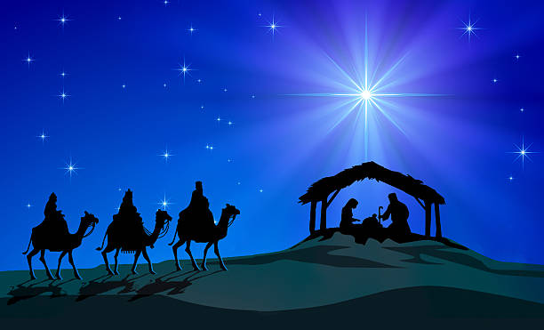

The Spontaneous Christmas Pageant
Christmas Eve
December 24, 2023
3:00 pm

The Spontaneous Christmas Pageant
*You may remain seated during the Hymns
**Whenever a Character/Leader says “We/I don’t believe it” the
congregation responds with “BELIEVE”

PRELUDE “When Christmas Morn is Dawning”

CALL TO WORSHIP
Leader: Do not be afraid; for see – I am bringing you good
news of great joy for all the people:
People: to you is born this day in the city of David a Savior,
who is the Messiah, the Lord.

HYMN 234 O Come, All Ye Faithful (vs. 1, 3, 6)
O come, all ye faithful, joyful and triumphant; O come ye to Bethlehem! Come, and behold him, born the King of angels! O come, let us adore him; O come, let us adore him; O come, let us adore him, Christ, the Lord!

Sing, choirs of angels; sing in exultation; O sing, all ye citizens of heaven about! Glory to God, all glory in the highest! O come, let us adore him; O come, let us adore him; O come, let us adore him; O come, let us adore him, Christ, the Lord!

Yea, Lord, we greet thee, born this happy morning; Jesus, to thee be all
glory given; Word of the Father, now in flesh appearing: O come, let us
adore him; O come, let us adore him; O come, let us adore him, Christ,
the Lord!

GREETING

SCRIPTURE LUKE 1:26-33

HYMN 240 Hark! The Herald Angels Sing (V. 1&2)
Hark! the herald angels sing, "Glory to the new-born King;
peace on earth, and mercy mild, God and sinners reconciled!"
Joyful, all ye nations, rise, join the triumph of the skies;
with th'angelic host proclaim, "Christ is born in Bethlehem!"
Hark! the herald angels sing, "Glory to the new born King!"

Christ, by highest heaven adored; Christ, the everlasting Lord;
late in time behold him come, offspring of a virgin's womb.

Veiled in flesh the Godhead see; hail th' incarnate Deity,
pleased with us in flesh to dwell, Jesus, our Emmanuel.
Hark! the herald angels sing, "Glory to the new-born King!"

SCRIPTURE Matthew 1:18b-24

HYMN 219 What Child is This (V. 1)
What child is this who, laid to rest, on Mary's lap is sleeping?
Whom angels greet with anthems sweet,
while shepherds watch are keeping?
This, this is Christ the King, whom shepherds guard and angels sing;
haste, haste to bring him laud, the babe, the son of Mary.

SCRIPTURE Luke 2:1, 3-5

HYMN 230 O Little Town of Bethlehem (V. 1&4)
O little town of Bethlehem, how still we see thee lie! Above thy deep and dreamless sleep, the silent stars go by. Yet in thy dark streets shineth the everlasting light; the hopes and fears of all the years are met in thee tonight.

O holy child of Bethlehem, descend to us, we pray; cast out our sin and enter in; be born in us today. We here the Christmas angels the great glad tidings tell; O come to us; abide with us, our Lord Emmanuel!

SCRIPTURE Luke 2:6-7

HYMN 217 Away in a Manger (V.1-3)
Away in a manger, no crib for his bed, the little Lord Jesus laid down his sweet head. The stars in the sky looked down where he lay, the little Lord Jesus asleep on the hay.

The cattle are lowing; the poor baby awakes, but little Lord Jesus, no crying he makes. I love thee, Lord Jesus; look down from the sky, and stay by my cradle til morning is nigh.

By near me, Lord Jesus; I ask thee to stay close by me forever and love me, I pray. Bless all the dear children in thy tender care, and fit us for heaven to live with thee there.

SCRIPTURE Luke 2:8-15

