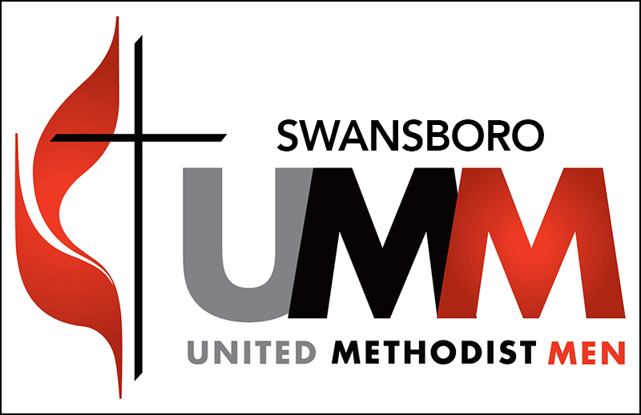

SUMM Board Meeting MINUTES 6:30 PM 16 February 2022

- Welcome/Prayers – President David Krawchuk and Chaplain Bill Smith.
- Fellowship & Program Meetings
  - Saturday morning Men’s Breakfast & Program planned for 19 March.
  - Men to cook and serve Easter Breakfast for Church and Community 17 April

- Peanut Ministry –2021 completed. 2022 planned.

  - Peanut Chair – outgoing of many years = Mel Guss. 2New 022 Chair = Greg Kizziah
  - Jars Coordinator – Bill Smith
  - On -line Orders – Frank Cizerle
  - Shipping Orders – David Krawchuk

- Treasurer’s Report – 2021 Status/Close Out and carry over to 2022 Donation Budget
Checking: Jan 1st Balance $24,216.61; Jan 31st Balance $20,038.57
Jan deposits $1,805.73 from peanut sales.
Jan outgoing $5,983.77. Outgoing included $3,200 from 2021 year-end donations and $2,000 for raw peanuts.
1/1/21 checking balance $17,014.48.
CD: $20,806 maturing on 7/16/22.
Jim Drum, Treasurer, SUMM
- Men’s Visitation Program – continues in 2022. Seeking men to do visiting once a month.
- Men’s Bible Study – open for ideas for short (4-6 week study). Call Bill Smith.
- Scouting –2022 continues with Troop and Boy-Girl-Sea Scouts.
- Open items – Fellowship to comment/vote on 2022 Board and Budget. See attached and below.
- Closed the meeting in Prayer – Chaplain Bill

--Secretary Frank Cizerle

