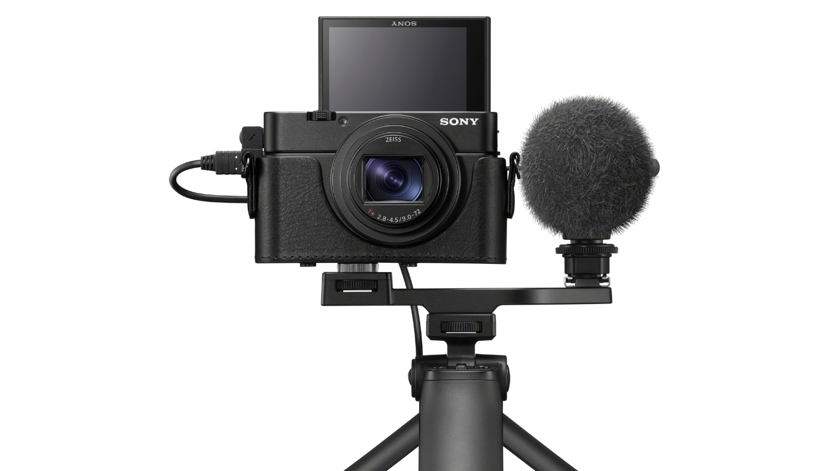
MEDIA CONSENT FORM AND RELEASE FOR MINOR CHILDREN

I am the parent/guardian of ________________________________________________________________ (print full name of child) (“My Child”).

I hereby grant Swansboro United Methodist Church (“SUMC”), and their agents the absolute right and permission to use photographic portraits, pictures, digital images, or videotapes of My Child, or in which My Child may be included in whole or part, or reproductions thereof in color or otherwise for any lawful purpose whatsoever, including but not limited to use in any SUMC publication or on the SUMC websites, without payment or any other consideration. I hereby waive any right that I may have to inspect and/or approve the finished product or the copy that may be used in connection therewith, wherein My Child’s likeness appears, or the use to which it may be applied. I hereby release, discharge, and agree to indemnify and hold harmless to SUMC and their agents from all claims, demands, and causes of action that I or My Child have or may have by reason of this authorization or use of My Child’s photographic portraits, pictures, digital images or videotapes, including any liability by virtue of any blurring, distortion, alteration, optical illusion, or use in composite form, whether intentional or otherwise, that may occur or be produced in the taking of said images or videotapes, or in processing tending towards the completion of the finished product, including publication on the internet, in brochures, or any other advertisements or promotional materials. I represent that I am at least eighteen (18) years of age and am fully competent to sign this Release.

PLEASE CHECK ONE OF THE BOXES BELOW THEN SIGN YOUR NAME(S):

☐ CONSENT: We/I hereby certify that We/I are/am the parent(s) or guardian(s) of the above-named child and do hereby give our/my consent without reservation to the foregoing on behalf of My Child.

☐ NON-CONSENT: We/I hereby certify that We/I are/am the parent(s) or guardian(s) of the above-named child and do not hereby give our/my consent without reservation to the foregoing on behalf of My Child.

_________________________________________________________________________________________ (Guardian’s Signature(s)) (Date)

_________________________________________________________________________________________ (Guardian’s Printed Name) (Primary Phone Number)

SM/20210311

