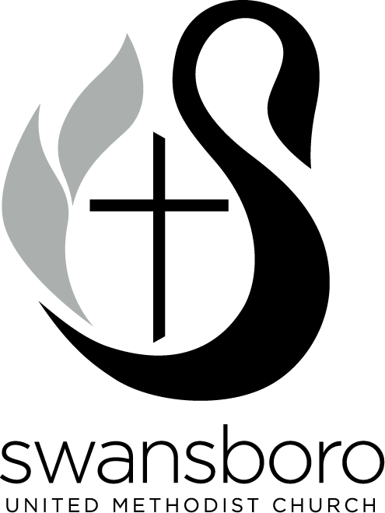
Swansboro United Methodist Church – 2021

I. Church Council

Leadership Ministry Area – Coordinator: Pastor Kevin Baker
Pastor: Adam Barth
Church Council Chair: Yana Frantz
Council Vice Chair: TBE
Recording Secretary: Marie Hurst
Lay Leader: Roger Fulp
Staff Parish Relations Committee Chair: John Mclean
Lay Delegates to Annual Conference: Tammy Taylor, Marilyn Boyce,
Alternate: Bren Feutz

Stewardship Ministry Area
Financial Secretary: Christy Denham
Stewardship Chair: David Wilmoth
Board of Trustees Chair: Tom Scholl
Treasurer: Joanne Kopanski
Finance Committee Chair: Peter Gante

Outreach & Nurture Ministry Area – Coordinator: Adam Barth
Missions / Serve Coordinator: Lisa Potts
Evangelism / Hospitality Chair: Tammy Taylor
United Methodist Men President: David Krawchuck
United Methodist Women President: Lynn Rouse
Communications Chair: Sanders Hall

Christian Education Ministry Area – Coordinator: Kevin Baker
Education Committee Chair: Susan Fulp; Student Ministries: Layne Harpine
Worship Committee Co-Chairs: Cleo Croom
Youth and Young Adult Representatives: TBD, Child Care Advisory Committee: Becky Dorris
AT LARGE MEMBERS: Kevin Frazier, Christine Dunston

II. Church Committees (alphabetical order)
- Board of Trustees
Provides supervision, oversight, and care of all real property owned by the local church and of all property and equipment acquired by the local church or by any board, class, or group connected with it. Reviews annually property, liability, buildings, equipment, insurance, etc; receives and administers all bequests made to local church.
Meets monthly.

Chairperson: Tom Scholl; Vice Chair: Jeff Conaway, Secretary: Paul Williams
2021  Mel Guss  Jeff Conaway  Patti Heller  Paul Williams | 2022  Jim Gamble  Tom Scholl  Becky Dorris | 2023  Elizabeth Holz  Barry Fetzer  Allan Tate
Ex officio members: Parsonage Committee Rep: Jane Sylvester; Childcare Rep: Becky Dorris
Trustees Sub Committees:
Parsonage Committee: Chairperson: Jane Sylvester; Susan Stuart, Sally Barnes, Cleo Croom

- Child Care Advisory Committee
Supports and helps to guide the ministry of our SUMC Child Care Ministry and works to strengthen this ministry and its relationship to the larger congregation. Works closely with the Child Care Director.
Meets approximately every other month.
Chairperson: Becky Dorris
2021  Anna Hall  Denise Baker | 2022  Becky Dorris  Laurie Nardo-Kunst | 2023  Janet Morgan  Gwen Macias
Director: Allison Cowell; Pastor: Kevin Baker
SPRC Rep: Lane Harris; Education Rep: Susan Fulp

- Communications Team
Helps the church "tell our story" as we seek to make a kingdom impact for God in our local community. Oversees internal and external communications including such things as website, emails, social media, signage, etc. Meets bi-monthly or as needed.
Chairperson: Sanders Hall
Alysia Barth, Kevin Baker, Denise Gartner, Neal Paul, Matthew Felipe, Dina Murray

- Education Committee
Plans and coordinates our spiritual formation ministry for all ages, with special focus on our kids and students. Includes visioning for ministries like children's church, children's ministries, VBS, college students, youth and young adults, family ministries, Sunday School, etc. Meets every other month.

Chairperson: Susan Fulp
Youth Ministry: Adam Barth, Layne Harpine; Children’s Church: Lisa Gibson; Children’s Ministries: Chris Wilson; College Students: Jennifer DeBeaumont

Child Care Advisory Committee: Becky Dorris,
Sunday School Superintendent: Megan Fahy; Nursery Coordinator: TBD;
At Large Members: Brian Licht, Wanda Conoway

- Evangelism and Hospitality Committee
Leads the congregation in reaching out to people with the good news of Jesus Christ and find innovative ways to welcome and receive new people into our congregation so they might develop spiritual friendships and grow in their relationship with God and others. Meets as needed.
Chairperson: Tammy Taylor; Hospitality Coordinator: Ashleigh Sewell
Merle Epperson, Sanders Hall, Adam Barth, Lynn Rouse, Arlene Speher,

- Finance Committee
Includes all areas of church financial stewardship: budgeting, operational expenses, legacy gifts, education (e.g. Financial Peace University), counting, communicating need and faithful reporting of gifts and needs to congregation, etc. Meets monthly.

Chairperson: Peter Gante, Vice Chair:
2021  David Sutton  Robbie Yates  Kirk Jones | 2022  Peter Gante  Phil Keagy  Carolyn Amdahl | 2023  Tonya Morton  Annette Harpine  Buddy Rogers
Committee includes: Church Council Chair: Yana Frantz; Board of Trustees Rep: ; Staff-Parish Rep: TBD; Stewardship Committee Chair: David Wilmoth, Financial Secretary: Christy Denham; Treasurer: Joanne Kopanski; Assistant Treasurer: TBD; Lay Leader: Roger Fulp; Lay Delegate to Annual Conference: Marilyn Boyce, Tammy Taylor

- Lay Leadership Committee
Responsible for nominating and organizing the members and chairs of each ministry area, committee, and team in the church on an annual basis. Per the Book of Discipline, it is chaired by the Pastor. Meets 3-4 times each fall unless otherwise noted.

Chairperson: G. Kevin Baker (Lead Pastor)
2021  Marlene Scott  Susan Del Grande  Carrie Morris | 2022  Chuck Egerton  Sue Young  Jan Butch | 2023  Mary Behan  Barbara Chandler  Andrea E. Wilmoth
Committee includes Lay Leader: Roger Fulp; Lay Members to Annual Conference: Marilyn Boyce, Tammy Taylor

- Missions / Serve Coordinator –Lisa Potts
Team does not meet regularly, but Coordinator may call a meeting of serve ministry point persons if needed.

Secretary: TBE
Appalachia Service Project (ASP): TBD
Church and Society: Andrea Wilmoth
Clothed in Righteousness: Abby Young
Congregations for Children (C4C): Peggy Stolzenberg
Disaster Relief: Layne Harpine
Food Missions:
Food Pantry: Susan Del Grande, Carol McLean
Hope Mission: Bobbi Edge
Manna: George Gardner
Rise Against Hunger: Jimmy Bean
Haiti Mission: Lynn Rouse
Kids Caring: TBD
Prison Ministry / Disciple Outreach Ministry (DBOM): Jermaine Gardner
The Refuge: Chip Olmstead
WOEOM Representative (The Hem): Lynn Rouse

- Staff Parish Relations Committee
Similar to a personnel committee; includes conferring with and counseling pastor and staff regarding effectiveness in ministry (gifts, skills, time, priorities for mission and ministry); evaluates pastors and staff annually; communicates and interprets to the congregation the nature and function of ministry in the UMC; develops and approves written ministry descriptions and titles for staff and oversees hiring; consults with pastor and staff concerning education, spiritual renewal, compensation, family needs, etc.
Meets monthly unless otherwise scheduled.

Chairperson: John Mclean Vice Chair: TBE. Secretary: TBE.
2021  Marcie Briley  Lane Harris  Bob Lenthall | 2022  Anna Hall  John Mclean  Julia Wax | 2023  Paula Roberson  Monte Morton  Gwen Macias
Committee includes Lay leader (Roger Fulp) and Lay Delegate to Annual Conference: Marilyn Boyce and Tammy Taylor

- Stewardship Committee
Works closely with our finance team and seeks to guide our congregation to grow in generosity with our time, talents, and financial gifts. Meets monthly or as needed.

Chairperson: David Wilmoth
2021  David Wilmoth  Andrea Wilmoth | 2022  Nanette Jones  Patricia Wriston | 2023  Beth Lenthall
Finance Committee Rep: Peter Gante

- Worship Committee
Our overall purpose is to collaborate with and support the pastoral staff and music leaders to provide
meaningful worship. Assists in developing seasonal and special services, oversee laity in their support
roles as greeters, ushers and acolytes. We coordinate the use of church facilities for weddings and
funerals.

Co-Chairs: Cleo Croom; Additional Co-Chair: TBD
Secretary: Nanette Jones, Acolytes: Susan Casper and Barbara Chandler; Communion: Sally Barnes; Flowers: Hal Silver; Visitor Gifts: Chaired by Gisela Fehr and Lynn Rouse; Funerals: Carol McLean; Music: Leah Czanderna; Name Tags: TBE; Ushers: Susan Stuart; Weddings: Jane Sylvester; Pastors: Adam Barth, Kevin Baker
At Large Members: Emily Egerton, Sanders Hall, Neva Tucker, Pat Wheaton, Carol Scull, Andrea E. Wilmoth

III. Other Ministries (printed for information)

Congregational Care –
Security Team Leader: Kevin Frazier
Church and Society: Andrea Wilmoth
Hand Made’ns: Sarah Austin
Martha’s Mission: Machelle Griffin, Jamie Garrett
SUMC Emergency Plan: Layne Harpine
The Lord’s Ladies: Linda Mack
SAM: Chair: Adele Brewster, Vice-Chair: Lynn Rouse, Team: Linda Mack

Updated 10/26/2020

