NOTES

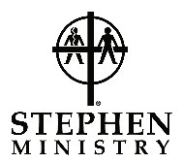

“Worship God, Love One Another, Serve the World”

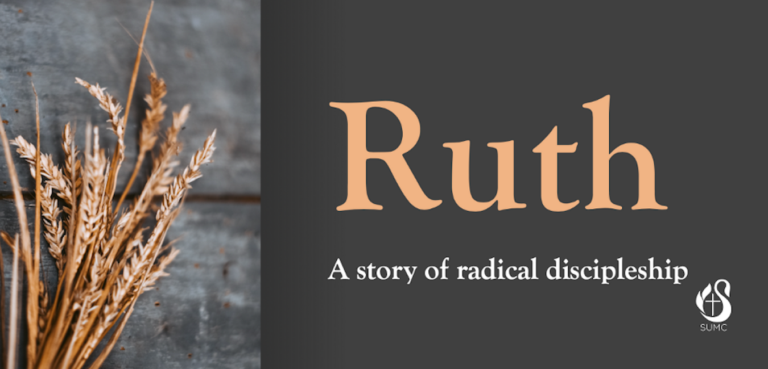

August 16, 2020
11:00 am
665 W Corbett Avenue
Swansboro, North Carolina 28584
910-326-4822
www.SwansboroUMC.org
Pastor G. Kevin Baker: pastorkevin@swansboroumc.org
Pastor Adam M. Barth: pastoradam@swansboroumc.org
Music Director: Merle Epperson: music@swansboroumc.org
Director of Contemporary Music: Leah Czanderna
beaconworship@swansboroumc.org

Contemporary Worship

Opening Song
“Glory to Glory”
Welcome and Announcements
Opening Prayer
Scripture Lesson
Ruth 2:1-13
Praise & Worship
“Indescribable” & “Redeemed”
Prayers of the People
Offering and Prayer of Dedication
“Oh My Soul”
Scripture Lesson
Ruth 2:14-23
Sermon
“When Hope and Despair Take a Walk”
Song of Commitment/Sending Forth
“We Believe”
Dismissal with Blessing

The congregation is asked to please wear a mask when moving closer to others not in your family/bubble and also if you sing along with hymns and songs. Help us model neighbor-love as we seek to keep all safe.

Membership in the United Methodist Church is open to all who confess Jesus Christ as Lord of their life. We recognize all former church memberships, baptisms or if you are uniting with a church family for the first time. If you desire to make Swansboro United Methodist Church your church family, please indicate so on the Connection Card provided in your pew, indicating the date and service you wish to be received. It makes a difference to have those you can call, “my church family.”

